18.2: a) The final temperature is four times the initial Kelvin temperature, or 4(314.15 K) –273.15=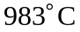 to the nearest degree.

